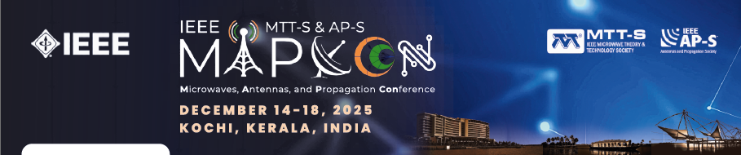

Special Sessions
Proposals for Special Sessions for the 2025 IEEE Microwaves, Antennas and Propagation Conference (IEEE MAPCON) in Kochi, India, are due by April 23, 2025. Special sessions will be selected and finalized by April 30, 2025. Special session paper submissions follow the regular submission process. The deadline for paper submission is July 28, 2025. Please ensure you select the appropriate special session during submission if you wish for the paper to be considered for that session.
Important Dates:
April 23, 2025 | Special Session Proposal Deadline (Extended)
April 30, 2025 | Special Session Acceptance Notification
July 28, 2025 | Special Session Paper Submission Deadline

This document is a template for all the information relevant to a special session proposal for MAPCON 2025. Please complete this form and submit it to Dr. Shobha Sundar Ram (shobha@iiitd.ac.in) for evaluation by the Special Session Committee.
Please use the following for the email subject line: MAPCON 2025 Special Session Proposal
IMPORTANT: Please carefully read the guidelines at the end of this document.

Special Sessions Proposal for IEEE MAPCON 2025

Session Title | x

Organizer(s): (Add more if required)
Name:
Affiliation:
Country:
Email: Telephone:

Brief description of the background in relation to the proposed session
Brief description of the topic
Papers
A special session requires eight papers. It is advisable to solicit more than eight contributions, as the submitted papers are subject to the regular paper review process.
Make a preliminary suggestion of authors and titles. Proposers must explain to potential authors that, at this stage, the session's acceptance cannot be guaranteed.
Author(s) | Affiliation, Country | E-mail | Paper Title

Special Sessions Guidelines
- Notes for proposers
Special Sessions are meant to be special. Topic areas may be new, novel, memorial, expository, revisited, etc. For example, Special Sessions may be focused on new research efforts or technology directions.
The proposal, including a provisional list of authors, must be submitted along with the proposal.
Special sessions can have more than one paper from each organizer's institution or more than one from each organizer as an author or co-author. In addition, the proposers must be aware that if the number of accepted papers is too low, the session might be filled with papers on allied topics or canceled.
- Information for Special Session Organization
Time length  of each Session | 120 minutes
Organizer(s)
Papers | Eight papers  (Diverse affiliations of authors preferred.)

- Paper Submissions
Special session paper submissions follow the regular submission process. If submitting to a special session, please select the appropriate one during submission. The accepted special sessions will be posted on the EDAS submission site after April 30, 2025. Please carefully read through the Author Information on Paper Submission website at https://ieeemapcon.org/.
- Selection Criteria
The selection process for Special Sessions will be based on a set of criteria:
- Quality of the solicited authors
- Topic of the session, taking into account the scientific content and the topical character
- Adherence to the above Recommendations Criteria
- Quality with respect to competing proposals
- Review Process
Please note that in order to ensure the same quality control as regular papers (including plagiarism and self-plagiarism), all papers submitted for a special session will undergo normal review process in MAPCON 2025.
Should you have any inquiries or questions, please contact the Special Session Chair or the TPC Co-Chairs.
Special Session Chair: Dr. Shobha Sundar Ram / E-mail: shobha@iiitd.ac.in
TPC Co-Chairs: Dr. Jasmin Grosinger, Email: jasmin.grosinger@tugraz.at and Dr. Jawad Y. Siddiqui, Email: jys.rpe@gmail.com

